Test Case: tc002_SPX_Dev5_Crear_Requisicion_Spot_Con_FAD_Tipo_Cobro_CC
Step 1 - Enter username and password and click to button Enter : Credentials Entered
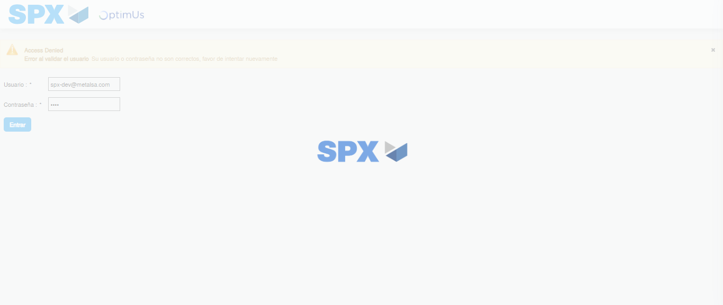Image file-name: QC_Testing-tc002_SPX_Dev5_Crear_Requisicion_Spot_Con_FAD_Tipo_Cobro_CC-1785960596364

Step 2 - Select to UEN and Access to Spot Buy Requisitions : UEN Correctly selected and Correct access
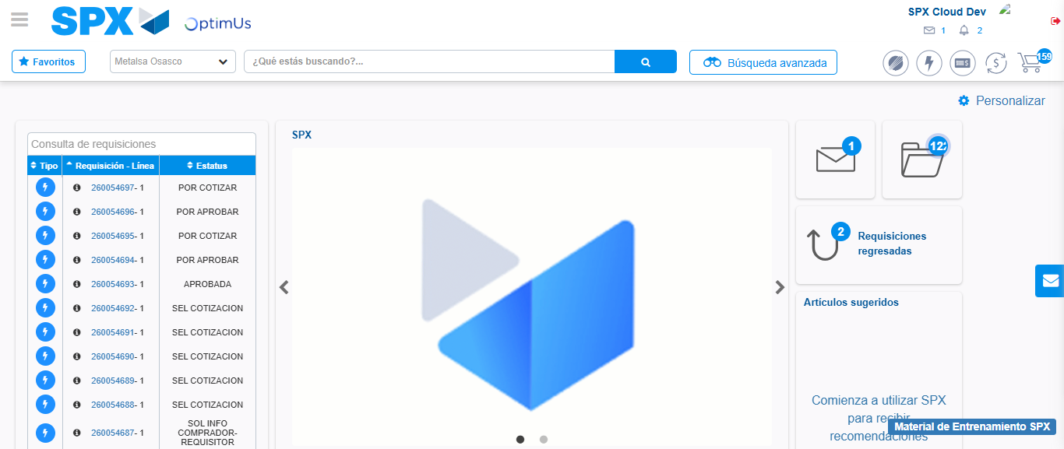Image file-name: QC_Testing-tc002_SPX_Dev5_Crear_Requisicion_Spot_Con_FAD_Tipo_Cobro_CC-1785960621098

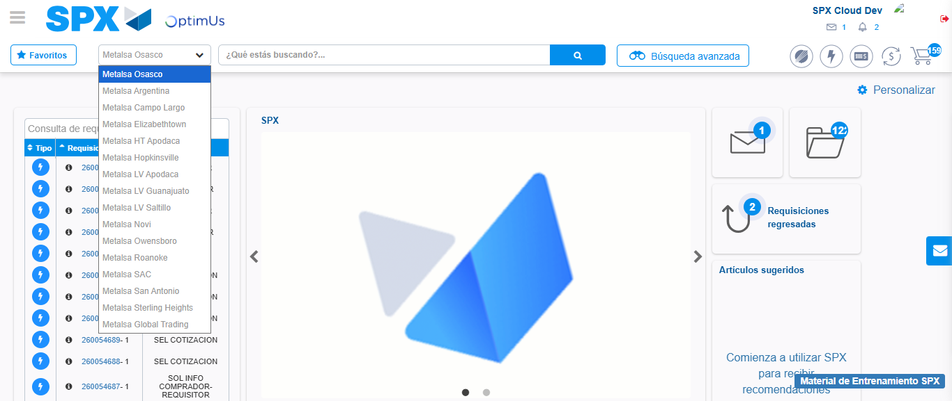Image file-name: QC_Testing-tc002_SPX_Dev5_Crear_Requisicion_Spot_Con_FAD_Tipo_Cobro_CC-1785960623686

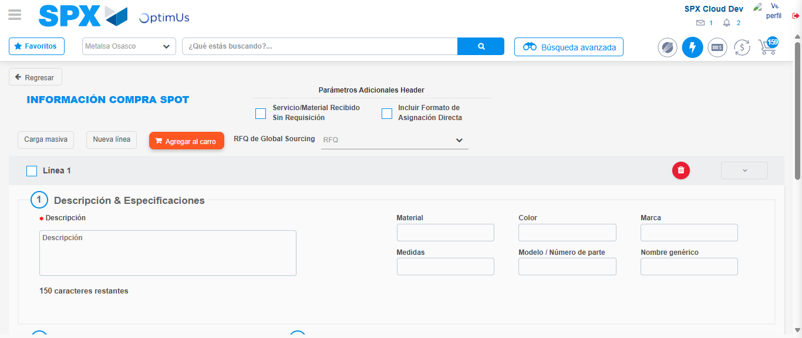Image file-name: QC_Testing-tc002_SPX_Dev5_Crear_Requisicion_Spot_Con_FAD_Tipo_Cobro_CC-1785960628549

Step 3 - Add FAD to Requisition: FAD Successfully Added
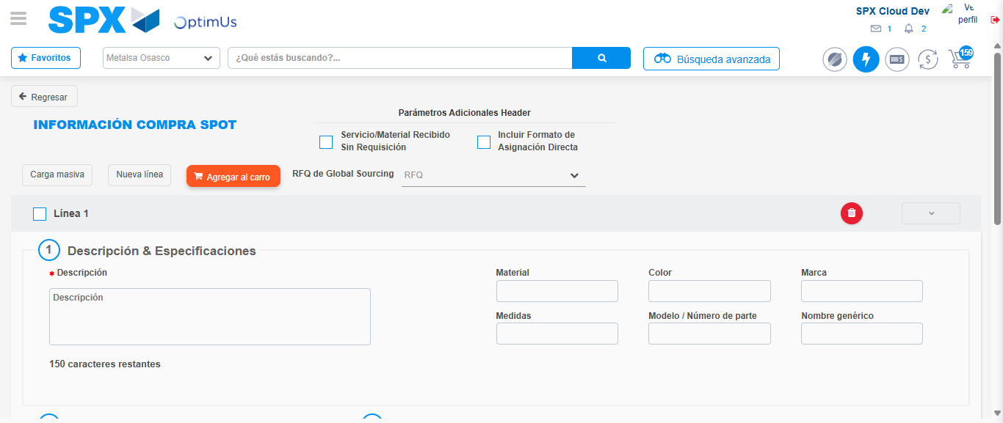Image file-name: QC_Testing-tc002_SPX_Dev5_Crear_Requisicion_Spot_Con_FAD_Tipo_Cobro_CC-1785960628768

Image file-name: QC_Testing-tc002_SPX_Dev5_Crear_Requisicion_Spot_Con_FAD_Tipo_Cobro_CC-1785960628984

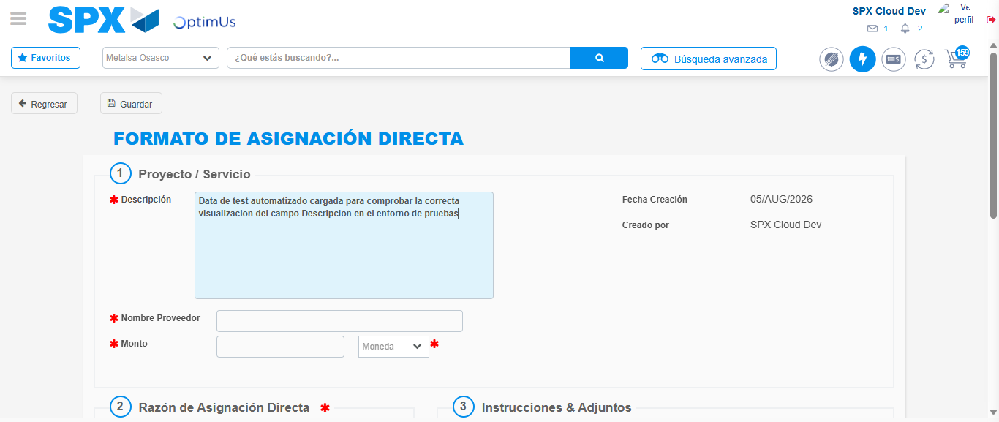Image file-name: QC_Testing-tc002_SPX_Dev5_Crear_Requisicion_Spot_Con_FAD_Tipo_Cobro_CC-1785960631695

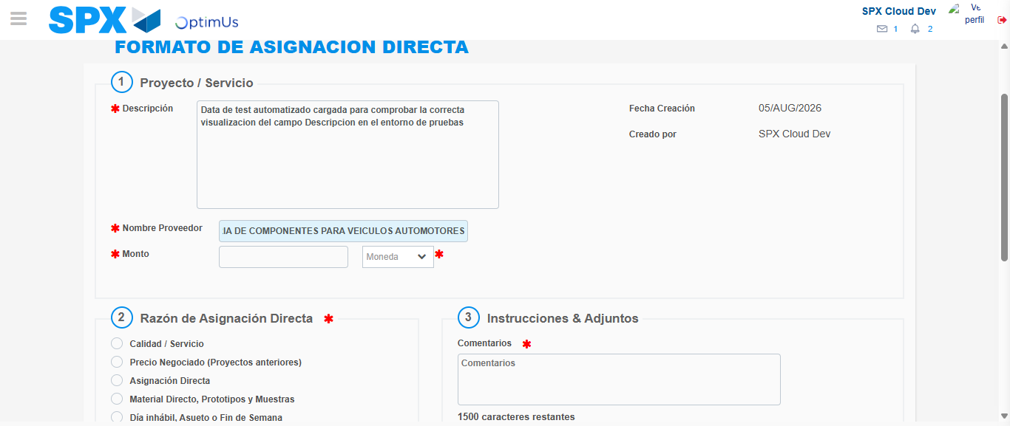Image file-name: QC_Testing-tc002_SPX_Dev5_Crear_Requisicion_Spot_Con_FAD_Tipo_Cobro_CC-1785960641274

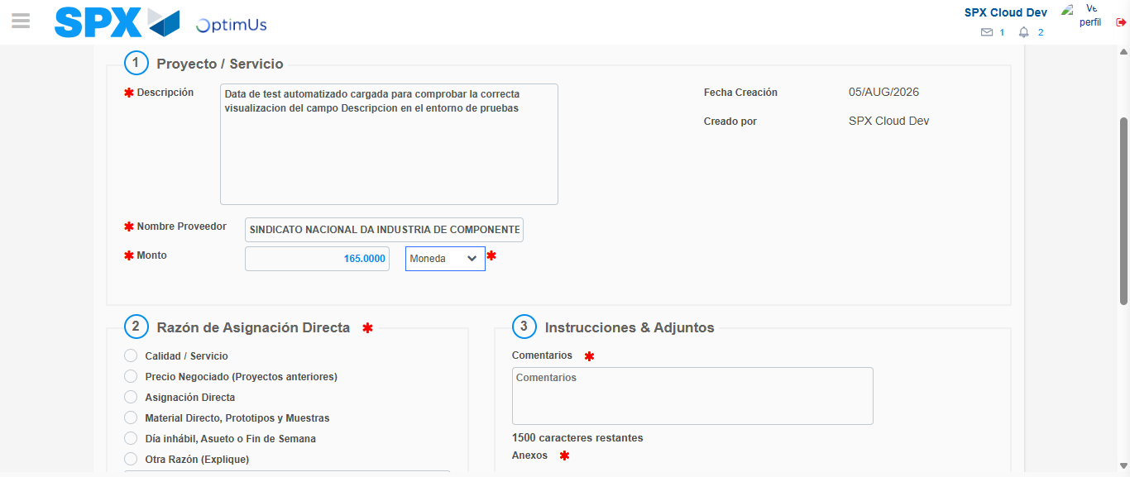Image file-name: QC_Testing-tc002_SPX_Dev5_Crear_Requisicion_Spot_Con_FAD_Tipo_Cobro_CC-1785960641658

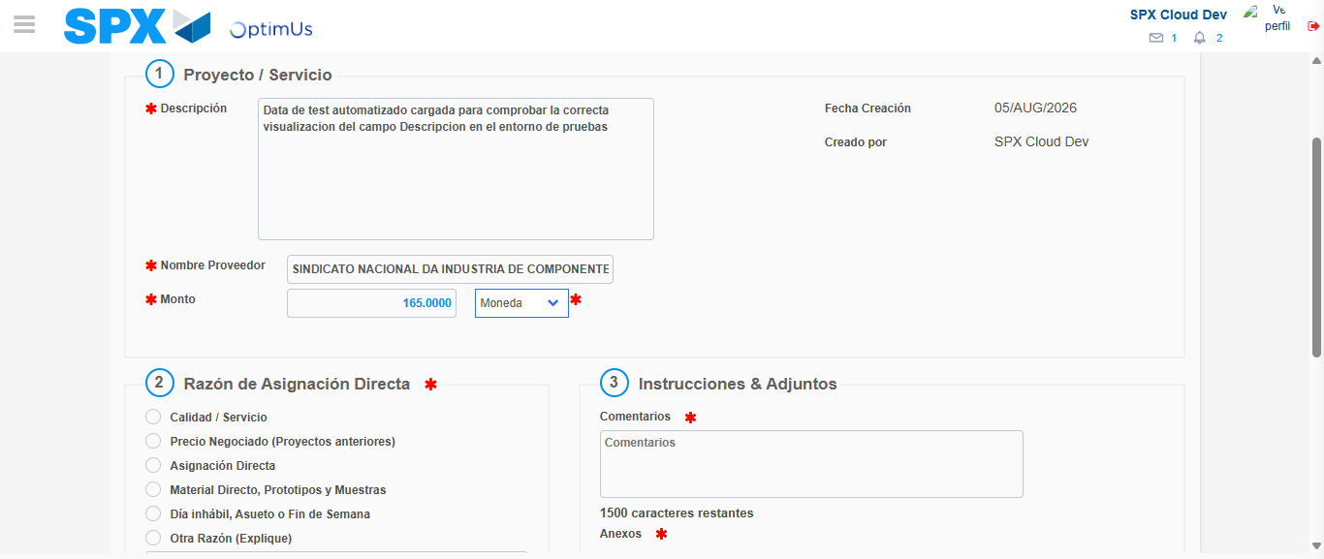Image file-name: QC_Testing-tc002_SPX_Dev5_Crear_Requisicion_Spot_Con_FAD_Tipo_Cobro_CC-1785960641831

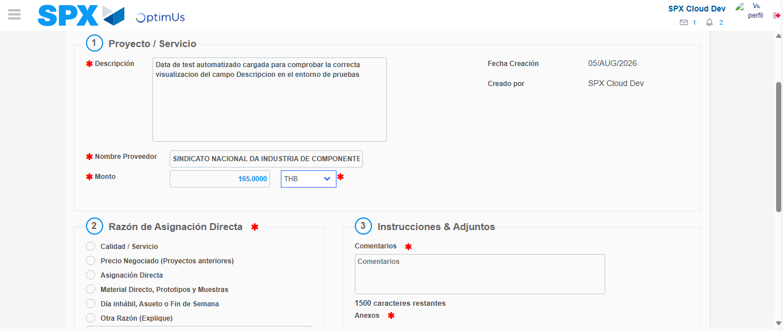Image file-name: QC_Testing-tc002_SPX_Dev5_Crear_Requisicion_Spot_Con_FAD_Tipo_Cobro_CC-1785960642154

Image file-name: QC_Testing-tc002_SPX_Dev5_Crear_Requisicion_Spot_Con_FAD_Tipo_Cobro_CC-1785960642331

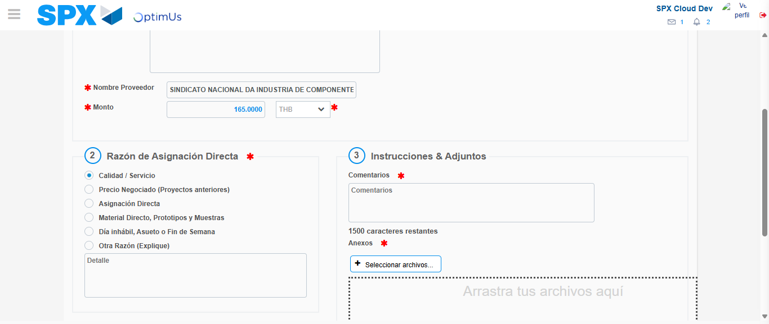Image file-name: QC_Testing-tc002_SPX_Dev5_Crear_Requisicion_Spot_Con_FAD_Tipo_Cobro_CC-1785960643149

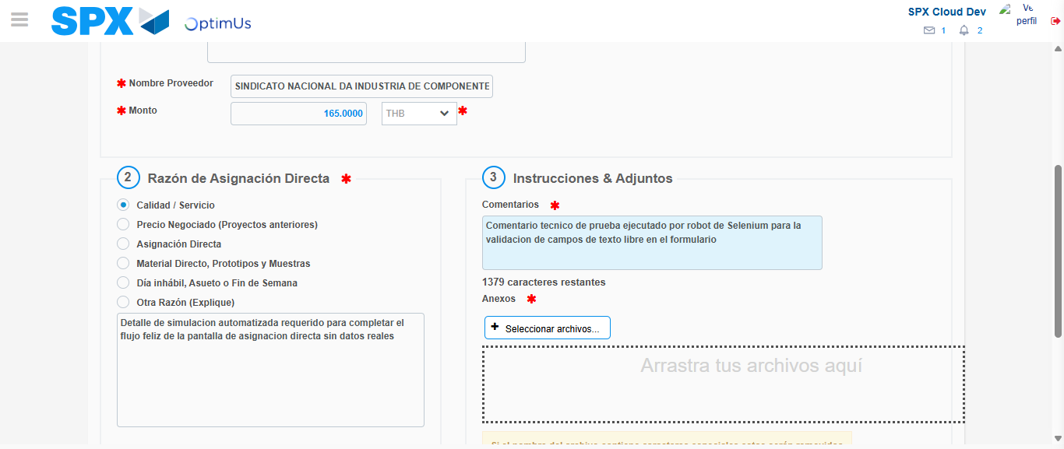Image file-name: QC_Testing-tc002_SPX_Dev5_Crear_Requisicion_Spot_Con_FAD_Tipo_Cobro_CC-1785960654141

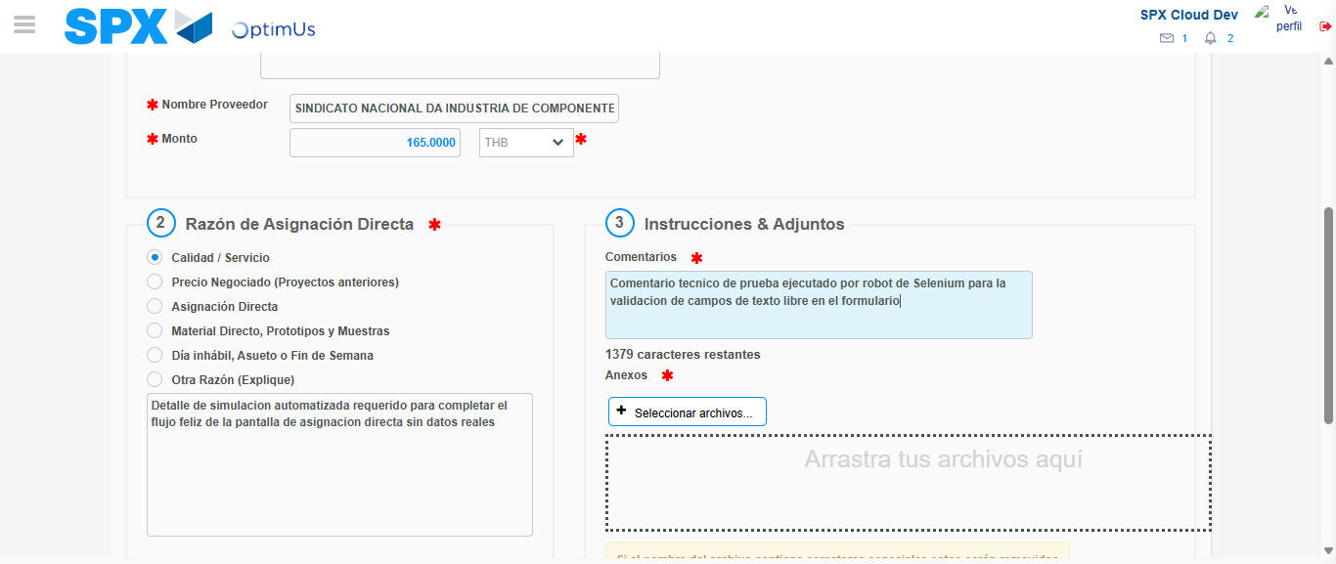Image file-name: QC_Testing-tc002_SPX_Dev5_Crear_Requisicion_Spot_Con_FAD_Tipo_Cobro_CC-1785960654724

Step 4 - Data Capture Spot Buy Requisition: Data captured correctly
Image file-name: QC_Testing-tc002_SPX_Dev5_Crear_Requisicion_Spot_Con_FAD_Tipo_Cobro_CC-1785960628768

Image file-name: QC_Testing-tc002_SPX_Dev5_Crear_Requisicion_Spot_Con_FAD_Tipo_Cobro_CC-1785960628984

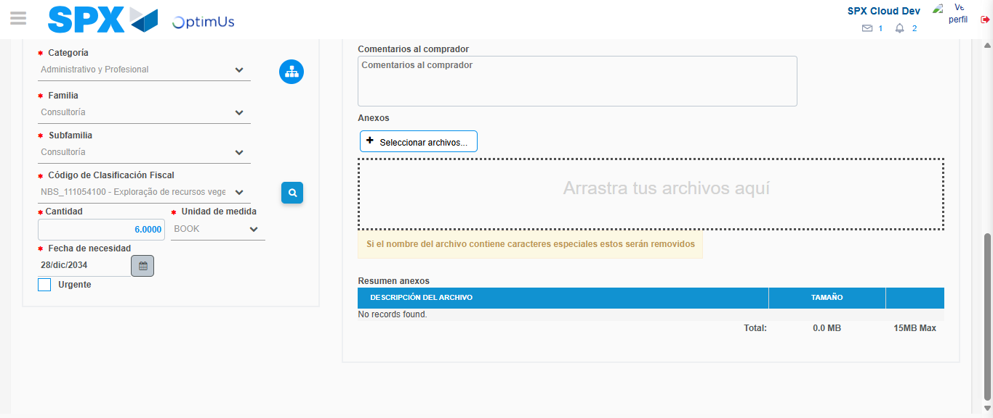Image file-name: QC_Testing-tc002_SPX_Dev5_Crear_Requisicion_Spot_Con_FAD_Tipo_Cobro_CC-1785960672069

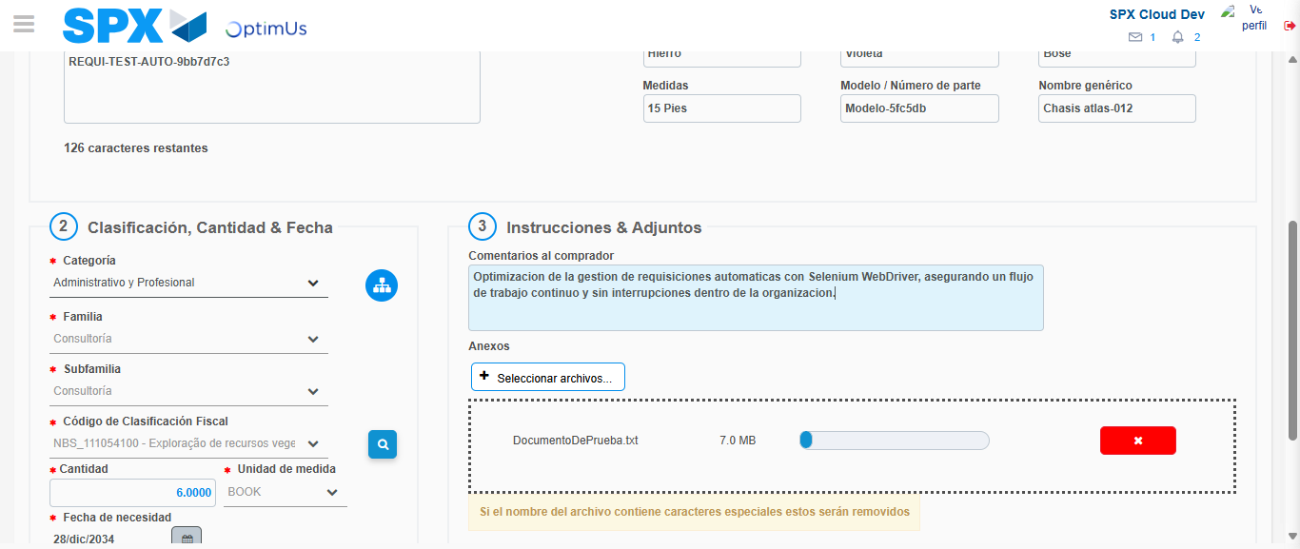Image file-name: QC_Testing-tc002_SPX_Dev5_Crear_Requisicion_Spot_Con_FAD_Tipo_Cobro_CC-1785960672834

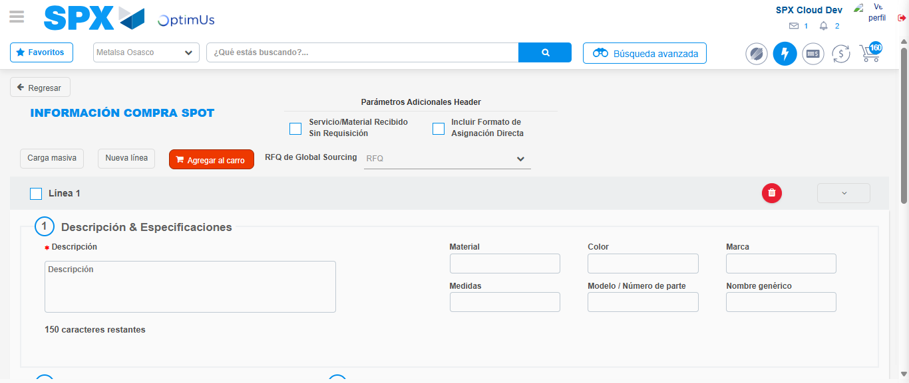Image file-name: QC_Testing-tc002_SPX_Dev5_Crear_Requisicion_Spot_Con_FAD_Tipo_Cobro_CC-1785960682891

Step 8 - Return to Main Page SPX : Return to Main Page SPX
Image file-name: QC_Testing-tc002_SPX_Dev5_Crear_Requisicion_Spot_Con_FAD_Tipo_Cobro_CC-1785960621098

Image file-name: QC_Testing-tc002_SPX_Dev5_Crear_Requisicion_Spot_Con_FAD_Tipo_Cobro_CC-1785960623686

Image file-name: QC_Testing-tc002_SPX_Dev5_Crear_Requisicion_Spot_Con_FAD_Tipo_Cobro_CC-1785960628549

Image file-name: QC_Testing-tc002_SPX_Dev5_Crear_Requisicion_Spot_Con_FAD_Tipo_Cobro_CC-1785960685139

Image file-name: QC_Testing-tc002_SPX_Dev5_Crear_Requisicion_Spot_Con_FAD_Tipo_Cobro_CC-1785960685319

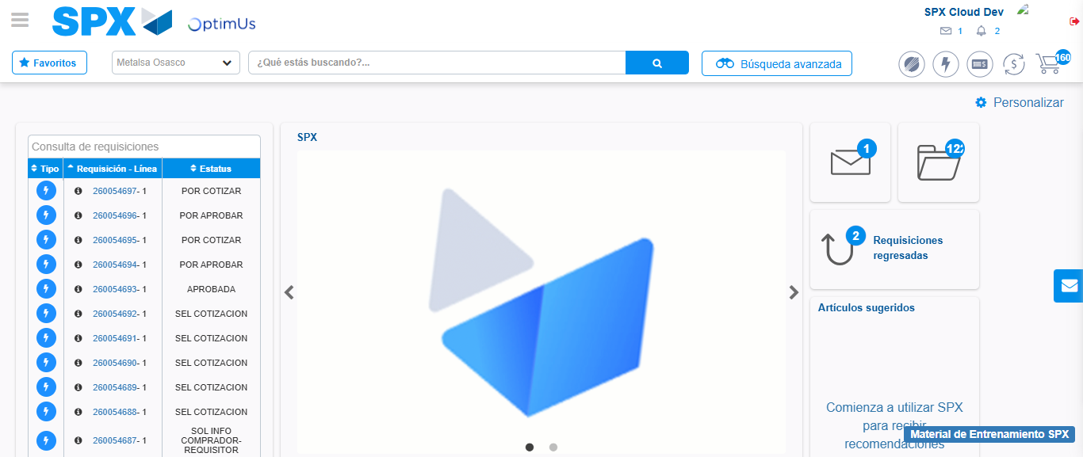Image file-name: QC_Testing-tc002_SPX_Dev5_Crear_Requisicion_Spot_Con_FAD_Tipo_Cobro_CC-1785960706524

Step 9 - Log Out : Log Out SPX
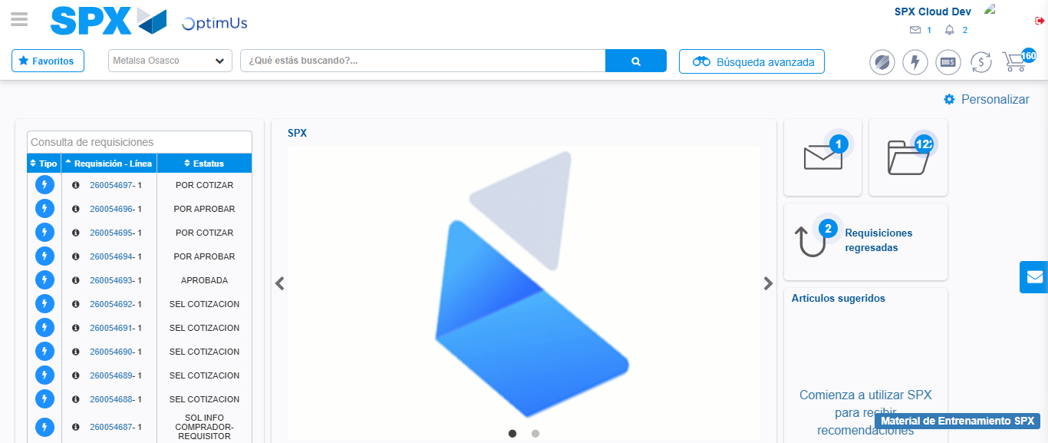Image file-name: QC_Testing-tc002_SPX_Dev5_Crear_Requisicion_Spot_Con_FAD_Tipo_Cobro_CC-1785960706819

